**JAVA REVIEW QUESTION**

**Submitted by**

Tamilvanan B.

2018503566.

MO Batch.

09-04-2020.

Create a java program that counts the number of objects created for a student result processing application through constructors. Also, try to create two non-reference object and invoke the garbage collection process. Use finalize method to analyze the result.

**Program:**

public class Student{

static int count;

char grage;

Student(){

count++;

}

Student(char ch){

System.out.println("The grade obtained is " + ch);

}

public static void main(String...strings) {

Student obj4 = new Student();

Student obj5 = new Student();

Student obj6 = new Student('A');

System.out.println("\nThe number of objects created is " + obj4.count);

obj5 = null;

System.gc(); //static method gc()

obj4 = null;

Runtime.getRuntime().gc(); /*allow the application to interfere JVM during runtime*/

}

public void finalize() throws Throwable{

System.out.println("\nGarbage collector invoked and object garbage collected is " + this);

}

}

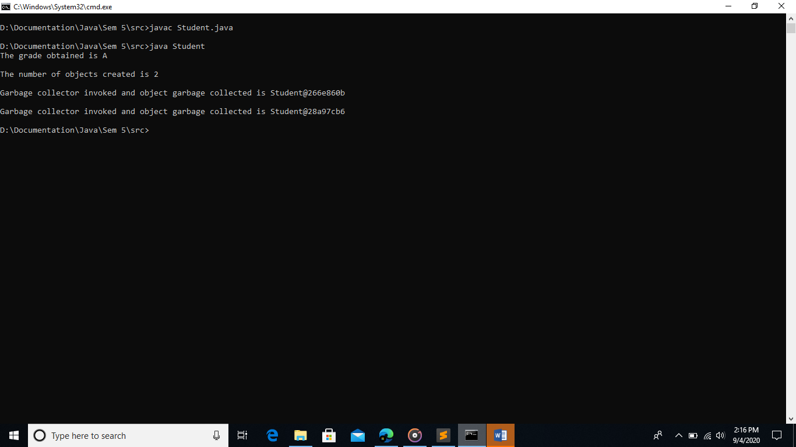**Output:**